Q1. Explain .Net framework architecture in detail. Also explain about the console, window and web applications offered by .Net framework.

.NET is a software framework which is designed and developed by Microsoft. The first version of .Net framework was 1.0 which came in the year 2002. In easy words, it is a virtual machine for compiling and executing programs written in different languages like [C#](https://www.geeksforgeeks.org/introduction-to-c/), VB.Net etc.  
It is used to develop Form-based applications, Web-based applications and Web services. There is a variety of programming languages available on the .Net platform, VB.Net and [C#](https://www.geeksforgeeks.org/introduction-to-c/) being the most common ones are . It is used to build applications for Windows, phone, web etc. It provides a lot of functionalities and also supports industry standards.

**Basic Architecture and Component Stack of .NET Framework**

The first three components from bottom are considered as the basic architecture of .Net

framework which came in the year 2005 and after this more components were added by

Microsoft in the .Net Framework as following :

[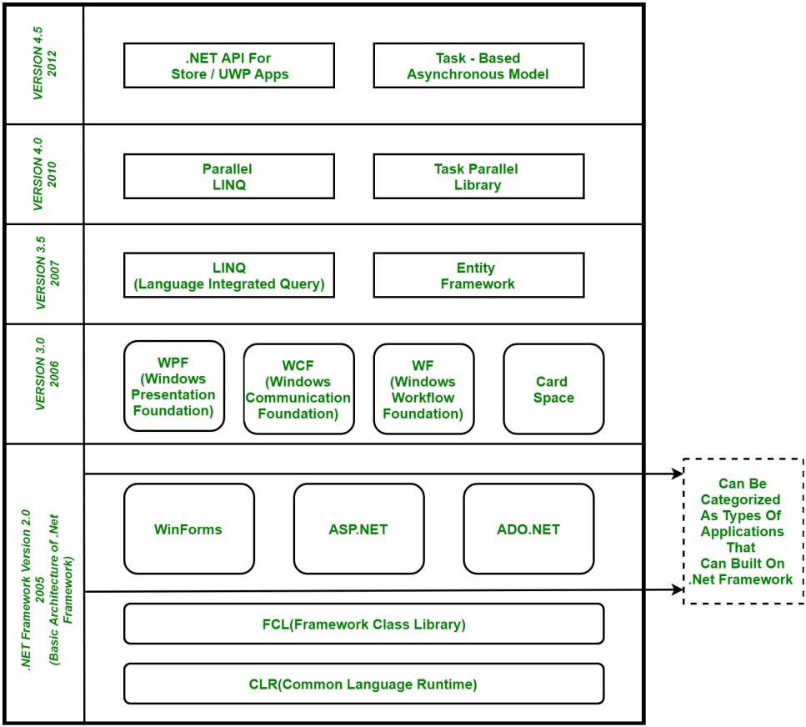](https://media.geeksforgeeks.org/wp-content/uploads/Net-Framework.jpg)

1. **CLR (Common Language Runtime) :** It is a run-time environment which executes the code written in any .NET programming language. .Net framework provides the support for many languages like [C#](https://www.geeksforgeeks.org/introduction-to-c/), F#, [C++](https://www.geeksforgeeks.org/c-plus-plus/), Cobra, Jscript.Net, VB.Net, Oxygene etc
2. **FCL (Framework Class Library) :** A large number of class libraries are present in this framework which is known as FCL.
3. **Types of Applications :** Mainly the applications which are built in .Net framework is divided into the following three categories :

* **WinForms :** Form – Based applications are considered under this category. In simple terms, we can say client based applications which read and writes the file system comes under this category.
* **ASP .NET :** Web-Based applications come under this category. ASP.Net is a framework for web and it provides the awesome integration of HTML, CSS and JavaScript which makes it useful to develop the web applications, websites and web services. **Web services were added in .Net Framework 2.0 and considered as a part of ASP.NET web applications.**
* **ADO .NET :** It includes the application which are developed to communicate with the database like MS SQL Server, Oracle etc. comes. It mainly consists of classes that can be used to connect, retrieve, insert and delete data.

1. **WPF (Windows Presentation Foundation) :** Windows Presentation Foundation (WPF) is a graphical subsystem given by Microsoft which uses DirectX and is used in Windows-based applications for rendering UI (User Interface). WPF was initially released as part of .NET Framework 3.0 in 2006 and previously known as **“Avalon”**.
2. **WCF (Windows Communication Foundation) :** It is a framework for building connected and service-oriented applications used to transmit the data as asynchronous from one service endpoint to another service point. It was previously known as the **Indigo**.
3. **WF (Windows Workflow Foundation) :**It is a technology given by Microsoft which provides a platform for building workflows within .Net applications.
4. **Card Space :**It is a Microsoft .NET Framework software client which is designed to let users provide their digital identity to online services in a secure, simple and trusted way.
5. **LINQ (Language Integrated Query) :** It is introduced in .Net framework version 3.5. Basically, it is a query language used to make the query for data sources with VB or [C#](https://www.geeksforgeeks.org/introduction-to-c/) programming languages.
6. **Entity Framework :** It is open–source ORM (Object Relational Mapping) based framework which comes into .Net Framework version 3.5. It enables the .Net developer to work with database using .Net objects. Before entity framework, .Net developers have performed a lot of things related database. Like to open a connection to the database, developers have to create a Data Set to fetch or submit the data to the database, convert data from the Data Set to .NET objects or vice-versa. It creates the difficulties for developers and also it was the error-prone process, then **“Entity Framework”** comes to automate all these database related activities for the application. So, Entity Framework allows the developers to work at a higher level of abstraction.

**Note :** **REST (Representational State Transfer)** and **AJAX**were added in .Net Framework 3.5 as an extension and services of ASP.NET for enhancing web services of .NET Framework.

1. **Parallel LINQ (Language Integrated Query) :** It comes in .Net Framework version 4.0 and also termed as PLINQ. It provides a concurrent query execution engine for **LINQ**. It executes the **LINQ** in parallel such that it tries to use as much processing power system on which it is executing.
2. **TPL (Task Parallel Library) :** It is a set of public types and APIs. It allows the developers to be more productive by simplifying the process of adding concurrency and parallelism to .Net applications.
3. **.NET API For Store/UWP Apps :** In 2012, Microsoft added some APIs for creating **UWP(Universal Windows Platform)** apps for Windows using [C#](https://www.geeksforgeeks.org/introduction-to-c/) or VB.
4. **Task-Based Asynchronous Model :** It is model used to describe the asynchronous operations and tasks in .Net Framework.

Q2. Develop a console application to accept the details of a student and display the output

using System;

using System.Collections.Generic;

using System.Linq;

using System.Text;

using System.Threading.Tasks;

namespace student

{

classProgram

{

privatestaticobject Toint;

staticvoid Main(string[] args)

{

int r;

string n,c;

float a1,a2,a3,total ;

Console.WriteLine("Enter student's ID:");

r=Convert.ToInt32(Console.ReadLine());

Console.WriteLine("Enter student's Name:");

n = Console.ReadLine();

Console.WriteLine("Enter student's cource");

c = Console.ReadLine();

Console.WriteLine("Enter student's assigment score:");

a1 = Convert.ToInt32(Console.ReadLine());

Console.WriteLine("Enter student's mid term score:");

a2 = Convert.ToInt32(Console.ReadLine());

Console.WriteLine("Enter student's final score:");

a3 = Convert.ToInt32(Console.ReadLine());

Console.WriteLine(" student's ID:");

Console.WriteLine(r);

Console.WriteLine("Enter student's Name:");

Console.WriteLine(n);

Console.WriteLine("Enter student's cource");

Console.WriteLine(c);

Console.WriteLine("Enter student's assigment score:");

Console.WriteLine(a1);

Console.WriteLine("Enter student's mid term score:");

Console.WriteLine(a2);

Console.WriteLine("Enter student's final sem score:");

Console.WriteLine(a3);

Console.ReadLine();

}

}

}

OUTPUT:-

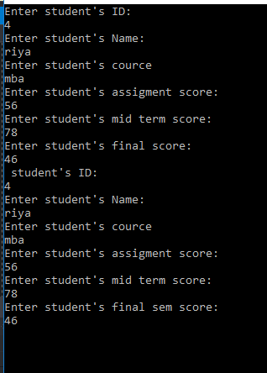

Q3. Develop a window application to Create, insert, delete and update data in to database using Execute-Non Query.

Design View:-

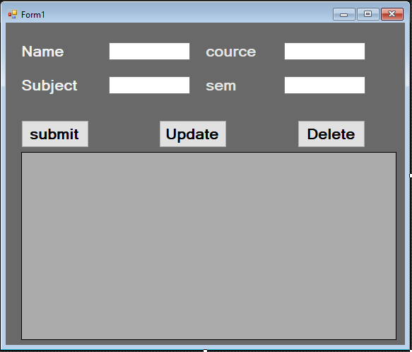

using System;

using System.Collections.Generic;

using System.ComponentModel;

using System.Data;

using System.Drawing;

using System.Linq;

using System.Text;

using System.Threading.Tasks;

using MySql.Data.MySqlClient;

using System.Windows.Forms;

namespace insert_update

{

publicpartialclassForm1 : Form

{

public Form1()

{

InitializeComponent();

}

privatevoid button3_Click(object sender, EventArgs e)

{

try

{

String myconnection = "datasource= localhost;port=3306;username=root;password=Dolly@0401";

MySqlConnection myconn = new MySqlConnection(myconnection);

MySqlDataAdapter MyDataAdapter = new MySqlDataAdapter();

MySqlCommand SelectCommand = new MySqlCommand("INSERT INTO project.opreation( name, cource,subject ,sem) VALUES ('" + this.textBox1.Text + "','" + this.textBox2.Text + "','" + this.textBox3.Text + "','" + this.textBox4.Text + "');", myconn);

MySqlDataReader myRead;

myconn.Open();

myRead = SelectCommand.ExecuteReader();

MessageBox.Show("name add");

gried();

}

catch (Exception ex)

{

MessageBox.Show(ex.Message);

}

}

void gried()

{

String myconnection = "datasource= localhost;port=3306;username=root;password=Dolly@0401";

MySqlConnection myconn = new MySqlConnection(myconnection);

MySqlCommand SelectCommand = new MySqlCommand("SELECT * FROM project.opreation", myconn);

try

{

MySqlDataAdapter sda = new MySqlDataAdapter();

sda.SelectCommand = SelectCommand;

DataTable dbdataset = new DataTable();

sda.Fill(dbdataset);

BindingSource bsource = new BindingSource();

bsource.DataSource = dbdataset;

dataGridView1.DataSource = bsource;

sda.Update(dbdataset);

}

catch (Exception ex)

{

MessageBox.Show(ex.Message);

}

}

privatevoid button1_Click(object sender, EventArgs e)

{

try

{

String myconnection = "datasource= localhost;port=3306;username=root;password=Dolly@0401";

MySqlConnection myconn = new MySqlConnection(myconnection);

MySqlDataAdapter MyDataAdapter = new MySqlDataAdapter();

MySqlCommand SelectCommand = new MySqlCommand("UPDATE project.opreation SET name = '" + textBox1.Text + "', cource = '" + textBox2.Text + "', subject = '" + textBox3.Text + "', sem = '" + textBox4.Text + "' WHERE id = '" + textBox6.Text + "'; ", myconn);

MySqlDataReader myRead;

myconn.Open();

myRead = SelectCommand.ExecuteReader();

MessageBox.Show("query update");

gried();

}

catch (Exception ex)

{

MessageBox.Show(ex.Message);

}

}

privatevoid Form1_Load(object sender, EventArgs e)

{

gried();

}

privatevoid dataGridView1_CellContentClick(object sender, DataGridViewCellEventArgs e)

{

if (e.RowIndex >= 0)

{

DataGridViewRow row = this.dataGridView1.Rows[e.RowIndex];

textBox6.Text = row.Cells["id"].Value.ToString();

textBox1.Text = row.Cells["name"].Value.ToString();

textBox2.Text = row.Cells["cource"].Value.ToString();

textBox3.Text = row.Cells["subject"].Value.ToString();

textBox4.Text = row.Cells["sem"].Value.ToString();

}

}

privatevoid button2_Click(object sender, EventArgs e)

{

Try

{

String myconnection = "datasource= localhost;port=3306;username=root;password=Dolly@0401";

MySqlConnection myconn = new MySqlConnection(myconnection);

MySqlDataAdapter MyDataAdapter = new MySqlDataAdapter();

MySqlCommand SelectCommand = new MySqlCommand("DELETE FROM `project`.`opreation` WHERE (`id` = '" + textBox6.Text + "');", myconn);

MySqlDataReader myRead;

myconn.Open();

myRead = SelectCommand.ExecuteReader();

MessageBox.Show("query deleted");

gried();

}

catch (Exception ex)

{

MessageBox.Show(ex.Message);

}

}

}

}

privatevoid dataGridView1_CellContentClick(object sender, DataGridViewCellEventArgs e)

{

if (e.RowIndex >= 0)

{

DataGridViewRow row = this.dataGridView1.Rows[e.RowIndex];

textBox6.Text = row.Cells["id"].Value.ToString();

textBox1.Text = row.Cells["name"].Value.ToString();

textBox2.Text = row.Cells["cource"].Value.ToString();

textBox3.Text = row.Cells["subject"].Value.ToString();

textBox4.Text = row.Cells["sem"].Value.ToString();

}

}

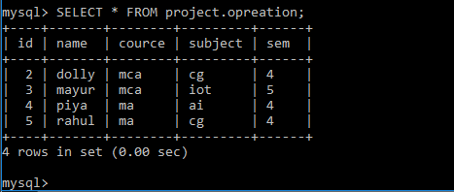

Insert Data:-

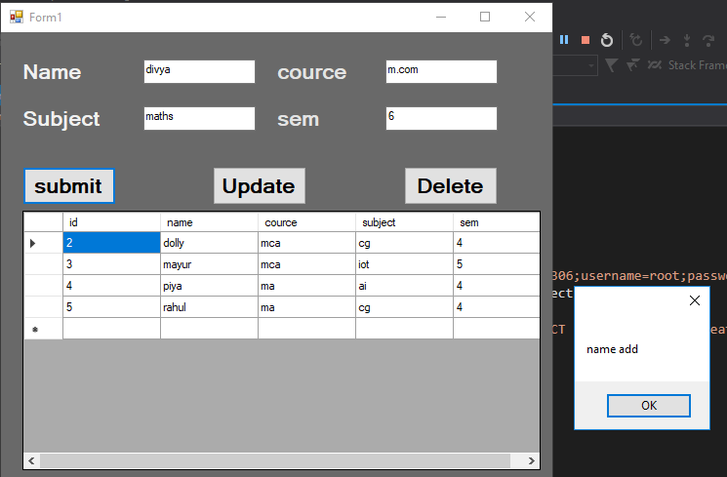

Update Data:-

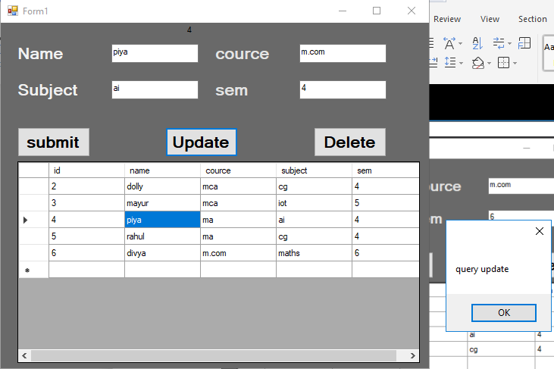

Delete Data:-

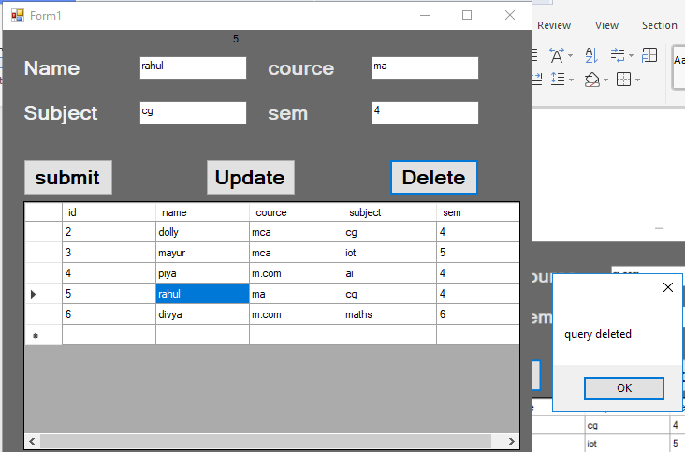

View Data:-

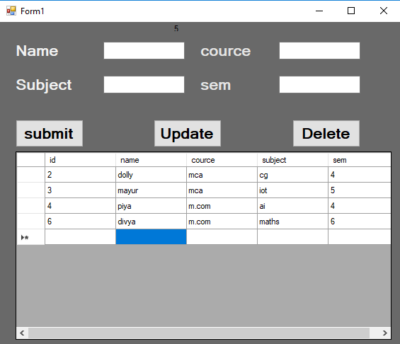

Q4. Develop a window application to generate the Login control.

Design View:-

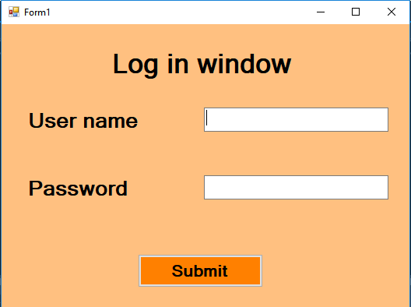

using System;

using System.Collections.Generic;

using System.ComponentModel;

using System.Data;

using System.Drawing;

using System.Linq;

using System.Text;

using System.Threading.Tasks;

using System.Windows.Forms;

using MySql.Data.MySqlClient;

namespace log_in

{

publicpartialclassForm1 : Form

{

public Form1()

{

InitializeComponent();

}

privatevoid Form1_Load(object sender, EventArgs e)

{

}

privatevoid button1_Click(object sender, EventArgs e)

{

try

{

String myconnection = "datasource= localhost;port=3306;username=root;password=Dolly@0401";

MySqlConnection myconn = new MySqlConnection(myconnection);

MySqlDataAdapter MyDataAdapter = new MySqlDataAdapter();

MySqlCommand SelectCommand = new MySqlCommand("SELECT * FROM project.login where user ='" + this.TextBox2.Text + "' and password ='" + this.TextBox1.Text + "';", myconn);

MySqlDataReader myRead;

myconn.Open();

myRead = SelectCommand.ExecuteReader();

int count = 0;

while (myRead.Read())

{

count = count + 1;

}

if (count == 1)

{

new Form2().Show();

}

else

{

MessageBox.Show("worng ans");

}

}

catch (Exception ex)

{

MessageBox.Show(ex.Message);

}

}

}

}

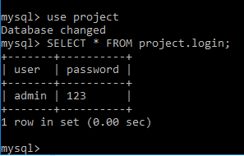

Enter User name & Password:-

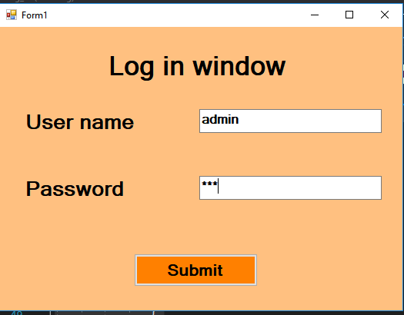

Enter Submit Button:-

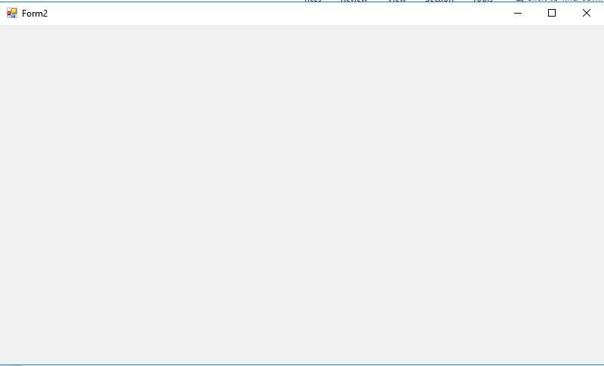

Q5. Develop a window application to display the all the basics detalis of an author and search records of an using database.

Design View:-

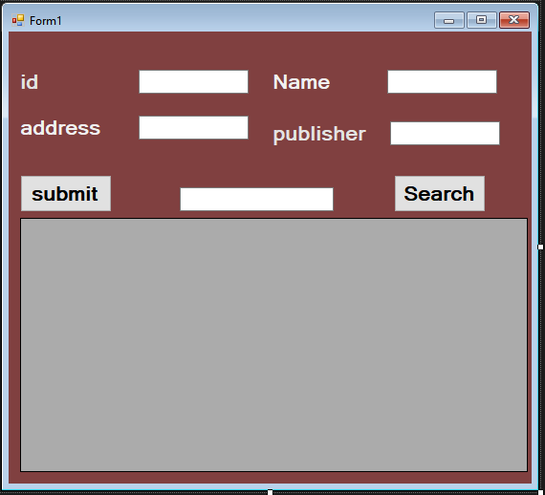

using System;

using System.Collections.Generic;

using System.ComponentModel;

using System.Data;

using System.Drawing;

using System.Linq;

using System.Text;

using System.Threading.Tasks;

using System.Windows.Forms;

using MySql.Data.MySqlClient;

namespace author

{

publicpartialclassForm1 : Form

{

public Form1()

{

InitializeComponent();

}

privatevoid Form1_Load(object sender, EventArgs e)

{

gried();

}

void gried()

{

String myconnection = "datasource= localhost;port=3306;username=root;password=Dolly@0401; database=project";

MySqlConnection myconn = new MySqlConnection(myconnection);

MySqlCommand SelectCommand = new MySqlCommand(" select author.a_id,author.a_name,author.a_address,publisher.p_book from publisher LEFT JOIN author ON author.a_id = publisher .a_id ; ", myconn);

try

{

MySqlDataAdapter sda = new MySqlDataAdapter();

sda.SelectCommand = SelectCommand;

DataTable dbdataset = new DataTable();

sda.Fill(dbdataset);

BindingSource bsource = new BindingSource();

bsource.DataSource = dbdataset;

dataGridView1.DataSource = bsource;

sda.Update(dbdataset);

}

catch (Exception ex)

{

MessageBox.Show(ex.Message);

}

}

privatevoid button3_Click(object sender, EventArgs e)

{

try

{

String myconnection = "datasource= localhost;port=3306;username=root;password=Dolly@0401";

MySqlConnection myconn = new MySqlConnection(myconnection);

MySqlDataAdapter MyDataAdapter = new MySqlDataAdapter();

MySqlCommand SelectCommand = new MySqlCommand("INSERT INTO `project`.author ( a_id,a_name,a_address ) VALUES ( '" + this.textBox1.Text + "' ,'" + this.textBox2.Text + "','" + this.textBox3.Text + "');", myconn);

MySqlDataReader myRead;

myconn.Open();

myRead = SelectCommand.ExecuteReader();

}

catch (Exception ex)

{

MessageBox.Show(ex.Message);

}

try

{

String myconnection = "datasource= localhost;port=3306;username=root;password=Dolly@0401";

MySqlConnection myconn = new MySqlConnection(myconnection);

MySqlDataAdapter MyDataAdapter = new MySqlDataAdapter();

MySqlCommand SelectCommand = new MySqlCommand("INSERT INTO `project`.publisher ( a_id, p_book) VALUES ('" + this.textBox1.Text + "','" + this.textBox4.Text + "');", myconn);

MySqlDataReader myRead;

myconn.Open();

myRead = SelectCommand.ExecuteReader();

MessageBox.Show("record add");

gried();

}

catch (Exception ex)

{

MessageBox.Show(ex.Message);

}

}

privatevoid button1_Click(object sender, EventArgs e)

{

String myconnection = "datasource= localhost;port=3306;username=root;password=Dolly@0401; database=project";

MySqlConnection myconn = new MySqlConnection(myconnection);

MySqlCommand SelectCommand = new MySqlCommand("select author.a_id,author.a_name,author.a_address,publisher.p_book from publisher LEFT JOIN author ON author.a_id = publisher .a_id where author.a_name='" + textBox5.Text + "' ; ", myconn);

try

{

MySqlDataAdapter sda = new MySqlDataAdapter();

sda.SelectCommand = SelectCommand;

DataTable dbdataset = new DataTable();

sda.Fill(dbdataset);

BindingSource bsource = new BindingSource();

bsource.DataSource = dbdataset;

dataGridView1.DataSource = bsource;

sda.Update(dbdataset);

}

catch (Exception ex)

{

MessageBox.Show(ex.Message);

}

}

}

}

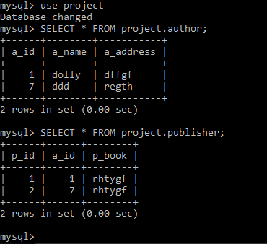

Add Record:-

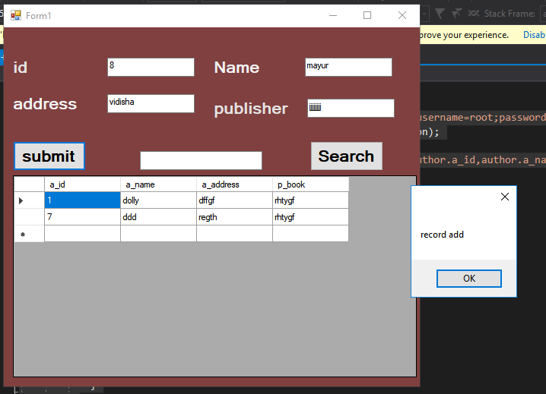

View Record:-

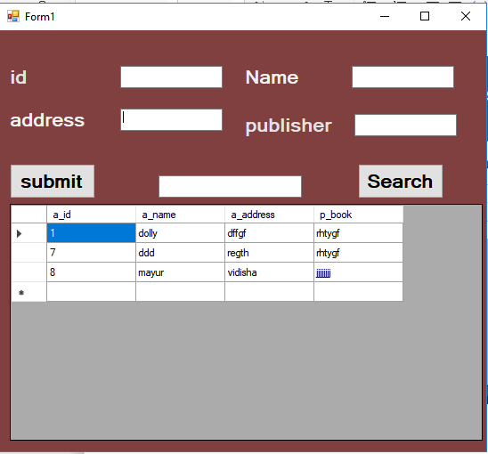

Search Record:-

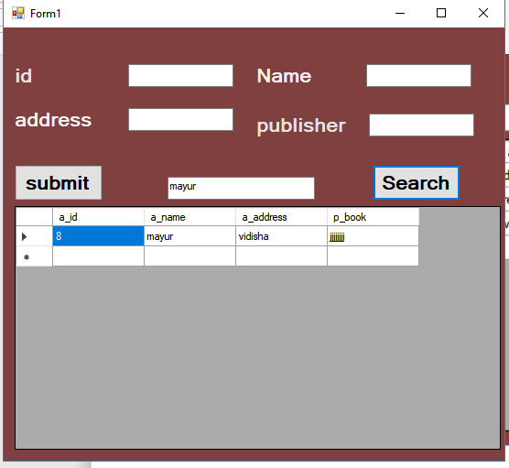

Q6. Develop a window application to display how data bind using dropdown list.

Design View:-

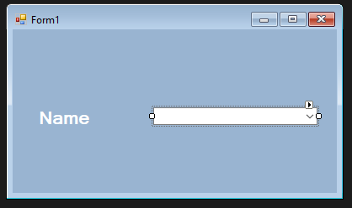

using System;

using System.Collections.Generic;

using System.ComponentModel;

using System.Data;

using System.Drawing;

using System.Linq;

using System.Text;

using System.Threading.Tasks;

using System.Windows.Forms;

using MySql.Data.MySqlClient;

namespace dropdown_app

{

publicpartialclassForm1 : Form

{

public Form1()

{

InitializeComponent();

}

privatevoid Form1_Load(object sender, EventArgs e)

{

fillcombo();

}

void fillcombo()

{

String myconnection = "datasource= localhost;port=3306;username=root;password=Dolly@0401";

MySqlConnection myconn = new MySqlConnection(myconnection);

MySqlCommand SelectCommand = new MySqlCommand("SELECT Name FROM world.city;", myconn);

MySqlDataReader myRead;

Try

{

myconn.Open();

myRead = SelectCommand.ExecuteReader();

while (myRead.Read())

{

String sname = myRead.GetString("name");

comboBox1.Items.Add(sname);

}

}

catch (Exception ex)

{

MessageBox.Show(ex.Message);

}

}

}

}

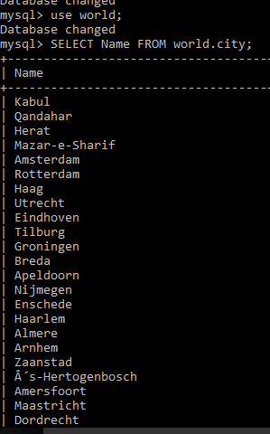

View Dropdown list:-

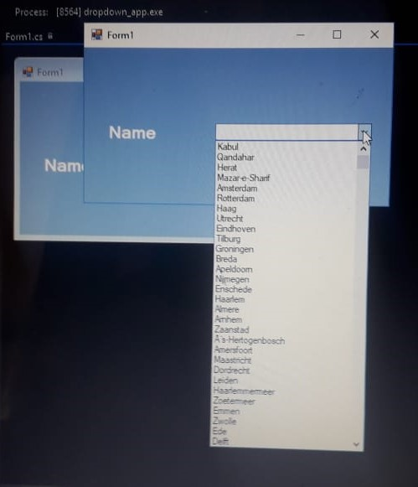

Select Name:-

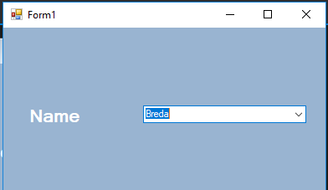

Q7. Develop a window application to bind data using data grid.

Design View:-

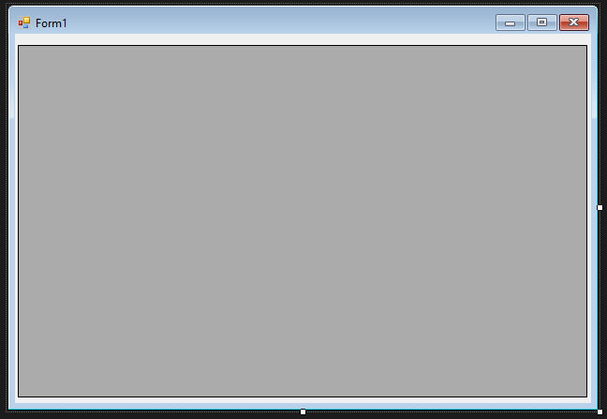

using System;

using System.Collections.Generic;

using System.ComponentModel;

using System.Data;

using System.Drawing;

using System.Linq;

using System.Text;

using System.Threading.Tasks;

using System.Windows.Forms;

using MySql.Data.MySqlClient;

namespace datagried_show

{

publicpartialclassForm1 : Form

{

public Form1()

{

InitializeComponent();

}

privatevoid Form1_Load(object sender, EventArgs e)

{

String myconnection = "datasource= localhost;port=3306;username=root;password=Dolly@0401";

MySqlConnection myconn = new MySqlConnection(myconnection);

MySqlCommand SelectCommand = new MySqlCommand("SELECT * FROM sakila.film;", myconn);

try

{

MySqlDataAdapter sda = new MySqlDataAdapter();

sda.SelectCommand = SelectCommand;

DataTable dbdataset = new DataTable();

sda.Fill(dbdataset);

BindingSource bsource = new BindingSource();

bsource.DataSource = dbdataset;

dataGridView1.DataSource = bsource;

sda.Update(dbdataset);

}

catch (Exception ex)

{

MessageBox.Show(ex.Message);

}

}

}

}

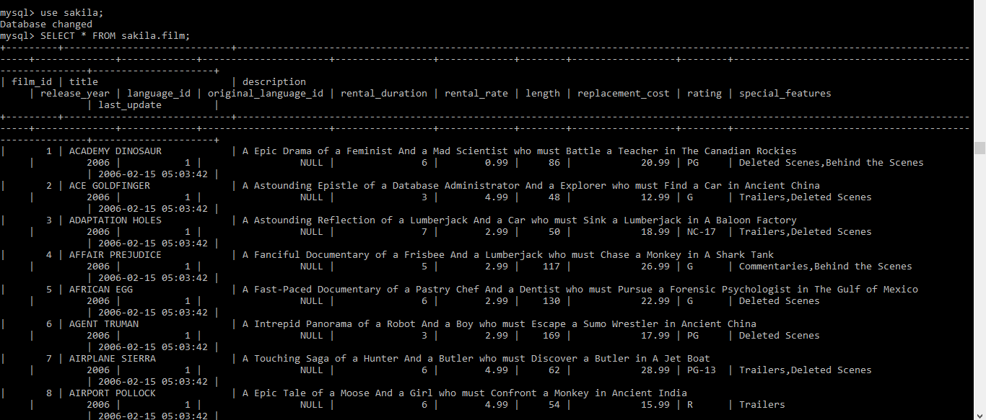

View Data:-

